2025 American Legion Medallion Hunt Clues
Clue #1:
35, 15, 190th, and 8.
Within these boundaries is where I wait.
On public land, not buried deep or high,
I rest where all can seek with watchful eye.
Clue #2:
Independence Day is why we play,
To honor those who paved our freedom’s way.
Where nature thrives and people walk around,
Among the fields, your prize is to be found.
Clue #3:
A city's heart holds lakes both big and small,
Where fishing, boats, and laughter greet us all.
Though waters call, stay far from waves so deep,
For where I hide, the forest’s path I keep.
Clue #4:
To find my spot, let pavement guide your feet,
A path well-trod where runners keep their beat.
No need to climb just sweep the ground,
Upon your stroll, just let your eyes wander around.
Clue #5:
A park named for a family long ago,
A haven where the kids and bikers go.
Not far from swings and places kids may play,
But off the beaten path, I hide away.
Clue #6:
Though Gotham's streets he used to roam,
This Robin's found a calmer home.
No cape, no mask, just wings to preen —
Perched up high, a quiet scene.
To find the prize, don’t watch the skies —
Look down where feathered friends may rise.
Clue #7:
Kulencamp Park—your journey ends at last,
Where players cheer and crowds engage,
Behind the dugout — not the stage.
No caped crusader, but still take note,
A robin’s home sits high, remote.
Below the nest, where logs may lie,
The medallion rests — give it a try!
Congratulations, Medallion Hunter Jamie Hafner!
2025 Winner of $500 with registered July 4th button!
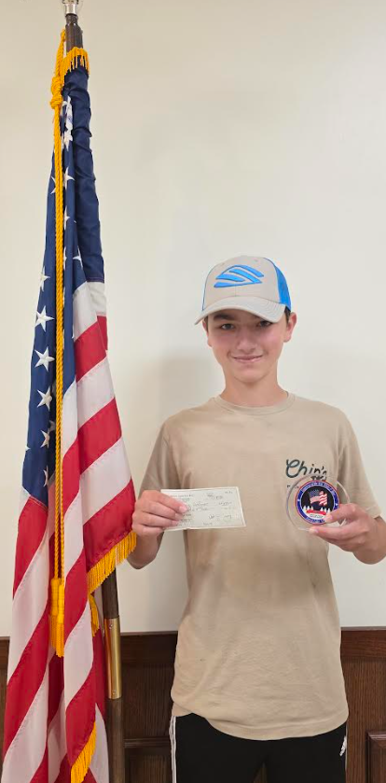
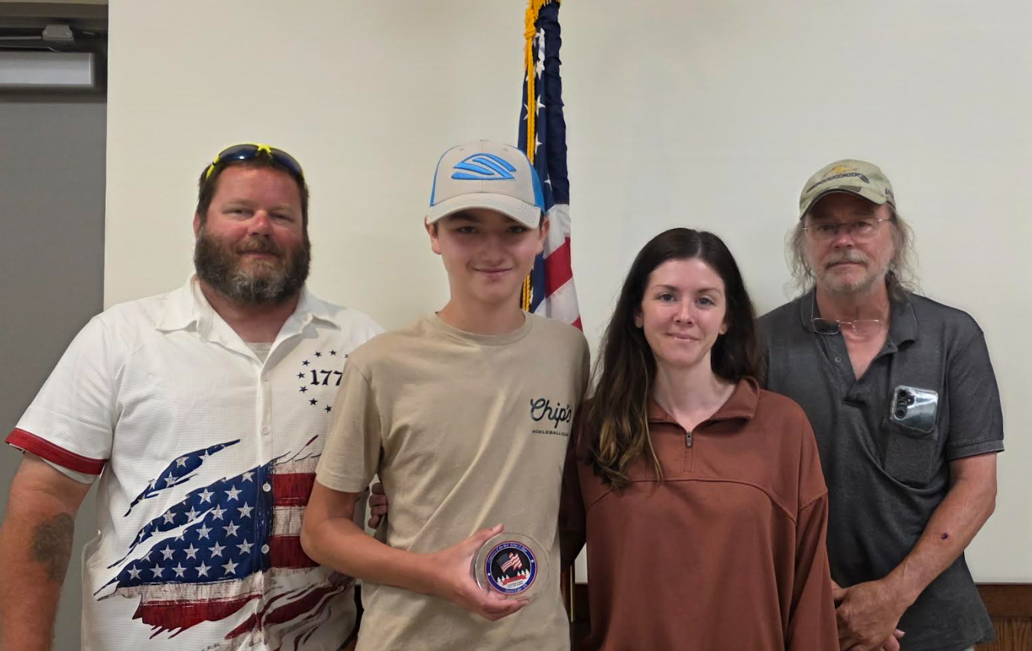
Dave Arend Jr (Clue Writer/Sons of the American Legion 3rd District Commander), Jamie Hafner (Medallion Hunter Winner), Shelby Hafner (Mom/Medallion Hunter), and Marc Wittibslager (Grandpa/Medallion Hunter)

Forest Lake Teen Finds American Legion Medallion and Funds a Dream Trip
Fourth Annual Post 225 July 4th Medallion Hunt Ends with a Family Win at David H Kulenkamp Memorial Park in Forest Lake
Forest Lake, MN — The spirit of community, tradition, and adventure shined bright this Fourth of July as 13-year-old Jamie Hafner uncovered the hidden medallion during the 4th Annual American Legion Post 225 Medallion Hunt in Forest Lake. With help from his mother, Shelby Hafner, and grandfather, Marc Wittibslager, Jamie found the prize tucked beneath a few small logs at the base of a tree near the baseball fields in David H Kulenkamp Memorial Park—right beneath a birdhouse and just off the walking path.
Since he purchased and registered his American Legion July 4th button, the discovery brings Jamie a $500 cash prize (his winnings would have been $250 without a registered button). Jamies plans to put his cash prize toward a school trip to Washington D.C., proving that persistence and teamwork really do pay off.
The Hafner family’s hunt was truly a team effort. “My dad helped for a while, too. We all texted each other. We hit all the parks,” Jamie said. Shelby recalled that Jamie played a lot of baseball at Kulenkamp Park as a younger kid, which led him to insist they go back there several times. It turned out to be the right call.
Marc admitted it wasn’t easy. “We searched Kulenkamp five times. On our fourth trip this morning, the mosquitoes were so bad we had to leave. We went to Mike’s Bait for bug spray, then went right back.” That’s when they spotted a small piece of plastic sticking out from under the logs. They initially thought it might be a geo tracker—until they opened the black box and found the real deal inside.
And they didn’t just search—they cleaned. “We were picking up trash as we went along,” said Marc. What a good way to give back while they hunted!
Jamie’s instincts—and some strategic Googling of Forest Lake parks—paid off. “The clues weren’t that helpful until the end,” he admitted. But the final clue sent them back to Kulenkamp Park with renewed focus.
The Belland family, who found the medallion in 2023 and 2024, had playfully challenged this year’s hunters on social media to work harder. Jamie and his family accepted that challenge—and now they’ll be smiling all the way to the bank.
And they weren’t the only winners this year. During the Forest Lake 4th of July parade, three additional $100 winners were randomly drawn: Kari Casserly, Becca Wojciak, and Lindsey Gatzow each received a crisp Franklin of their own — proving that even if you didn’t find the medallion, showing up still pays off!

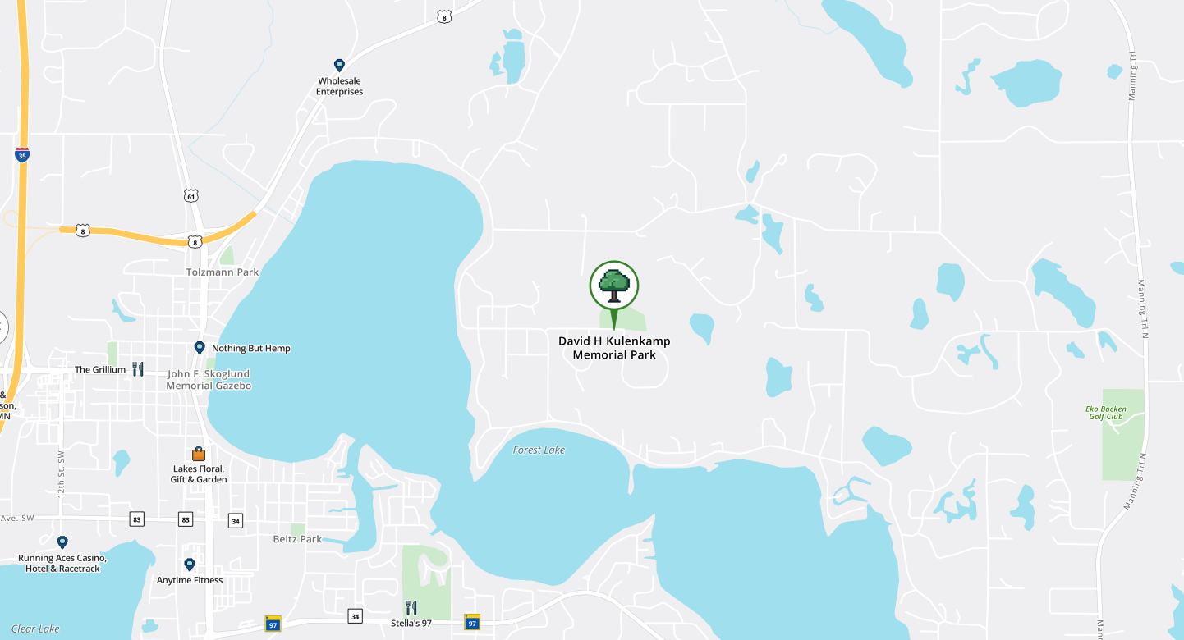
By Wendy Arend,
American Legion Auxiliary Unit 225
ALA 3rd District Executive Committee

